Ocean Adventure Field
Native vs Nonnative
Time: 12 minutes
Group Size: 10-15 Students
Grade Levels- 3rd – 8th grade
Location: Native Plant Garden

OVERVIEW OF ACTIVITY

Students learn to make good observations to help them identify plants in our garden. After identifying plants, they learn about natives and non-natives by discussing their different adaptations. At the end of the station, the students will be able to understand what makes the coastal chaparral habitat unique and special.

PERFORMANCE OBJECTIVES

Students will be able to:
- Use a dichotomous key to identify native plants in the native plant garden.
- Use a field guide to identify native plants in the native plant garden.
- Discuss adaptations that native plants have to the coastal habitat.

CHALLENGE

Identify one or more native plants, along with one or two non-native plants. Observe the adaptations and leaf structure of these plants to determine whether they are native or non-native. Observe human impact on the area to discuss solutions.

MATERIALS

Materials per group:
- One bucket
- Native Plant Garden field guides (at least five)
- Native plants dichotomous keys (at least five)

ADVANCE PREPARATION

- Place bucket with both the guides and keys inside of it on the table right outside of the Ocean Institute closest to the fire pit before the program starts.

TEACHING TIPS
- Use any plant in the native garden to model how to use the dichotomous key to identify a plant.
- Give students boundaries for their exploration.

PROCEDURE

Engage: (5 minutes)
- Lead your entire group to your first plant, preferably one with interesting characteristics (strong aroma ie. coastal sage brush).
- Explain how to use a dichotomous key to identify this plant and discuss characteristics and adaptations that you notice.
- Explain that the local coastal habitat does not get a lot of rainfall and is warm for most of the year. Ask students to identify characteristics about this plant that show how they are adapted for their native habitat (small leaves reduce water loss through evaporation, thick leaves store water, lighter colors help leaves reflect sun, etc.).

Explore: (20 minutes)
- Have students form groups of 3-4 and ensure that each group has a field guide and at least one dichotomous key. As you walk throughout the native plant garden, stop in a few places and have the students identify certain plants. Go ahead and direct the student groups to specific plants.
- After each group has identified 3 different plants, find a place to stop where you can sit and discuss.

Explain & Extend: (3-5 minutes)
- As a group, discuss what they discovered about their plants and whether they think they are native or nonnative. Have them notice how the differences help native plants survive in areas depending on specific abiotic factors.
- What made the native plants different from the nonnative plants? (Leaf shape, color, thickness, some with waxy coating, etc.)
- What makes a nonnative plant adapted to surviving and taking over a new area? (Answers will vary. May grow faster, use chemicals, the pollen goes further, etc.)
- Overtime, how will invasive species affect this ecosystem? Can or does this happen in other ecosystems? (Answers will vary.)

Evaluate: (2 minutes)
- How could human impacts affect the distribution of native or non-native plants in this area? (Facilitate student discussion.) What is a possible solution for reducing non-native species in the native plant garden?

BACKGROUND FOR ACTIVITY

VOCABULARY

- Native- living or growing naturally in a particular region; indigenous; grown, produced, or originating in a particular place or in the vicinity.
- Non-native- living or growing in a place that is not the location of its natural occurrence.
- Invasive- growing and dispersing easily usually to the detriment of native species and ecosystems.
- Adaptation- adjustment to environmental conditions, such modification of an organism or its parts that makes it more fit for existence under the conditions of its environment. A heritable physical or behavioral trait that serves a specific function and improves an organism’s fitness or survival.

The plants here are adapted to a Mediterranean climate, which is unique in that the wet season coincides with the low sun or winter period. Summers are dry. Total annual precipitation ranges between 15 and 40 inches per year. Temperatures are those of the subtropics- moderated by maritime influence and fogs associated with the cold ocean currents. The result is a very limited, but predictable, growing season when there is both sufficient soil moisture and adequately warm temperatures. Many plants are adapted to withstand drought often by having small, vertical, and/or waxy leaves to conserve water, the limiting resource.

Dichotomous keys are resources in which you can pick out individual plant characteristics that help scientists distinguish species type. In plants one way in which we can identify them is through leaf morphology. Leaves are generally made up of a blade or a lamina. Leaves on plants can be as simple as containing one leaf blade or compounded and contain several leaflets. From the leaf, the petiole is the stalk that links leaves to the stem. Scientists typically note both the shape and the edge of the leaf to help us identify species. Leaf venation or the way the veins of a leaf are arranged can also tell us about certain species. Leaves can have parallel venation where the veinlets run parallel across the lamina, or they can be reticulate where veinlets are arranged randomly. Phyllotaxy, or the way in which the leaves are arranged on the stem are also another distinguishing characteristic. See images below for reference.

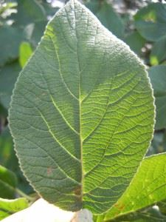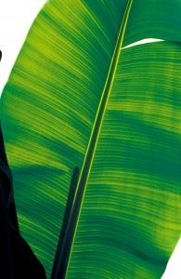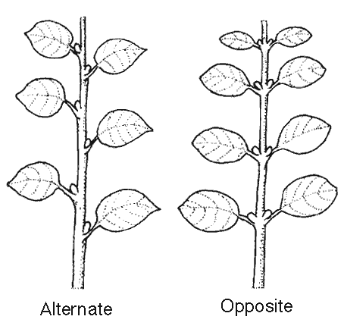
Reticulate venation Parallel venation Leaf phyllotaxy

Wildflowers are another important aspect of plant identification. Plants that flower do so for reproduction. Flowers however take a tremendous amount of energy on the plants part to produce. Flower anatomy can vary, but generally includes four main structures: pistils, stamens, petals, and sepals. Stamens are the male reproductive structures of a flower and contain the anther on the end which produces pollen. Stamen count will vary depending on the species and can aid in wildflower identification. The pollen produced in the Stamen of most plants will eventually need to be transferred to another parent plant for fertilization. The pistil is in the center of the flower and is the female reproductive structure. The pistil contains a stigma at the top that traps pollen and that pollen down to the ovary that contains the egg cells. When a wildflower is pollenated, the ova produces seeds that will eventually bloom into future wildflowers. Petals of a wildflower are generally colorful and showy and are used to attract pollinators. Outside of the petal is the sepal, which protects the wildflower and can even close during budding or stormy conditions in some plants. See picture below for visual reference of anatomy.

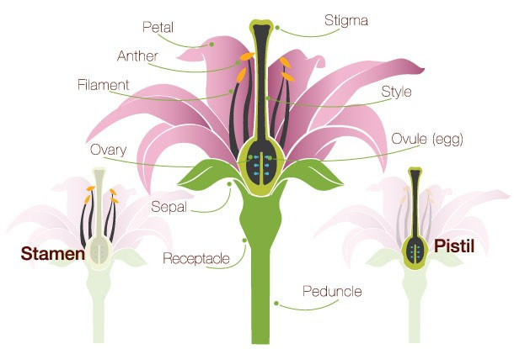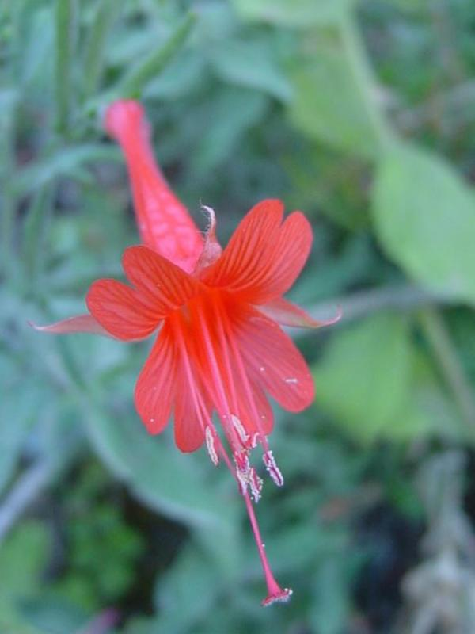

Native plants are an important part of the environment that helps sustain the ecosystem. Animals that live in California are adapted to and rely on Native plants as a food source. Hummingbirds, butterflies, insects, and even other plants all rely on the presence of native plants in the environment. In addition to the ecological benefit, native plants can also be used in place of traditional ornamental plants or small-rooted grass lawns. Since natives are adapted to the climate, they would not require additional watering, which in the long-term helps to conserve both water and time. Natives also do not require any fertilizers or pesticides that are traditionally used in gardens or lawns.

Humans are gradually encroaching on native plant habitats, and impacts are already clearly evident. The California Department of Fish & Wildlife currently lists 219 species, subspecies, and varieties of native plants throughout the state as rare, threatened, and endangered. In addition, nearly 2,000 more plant taxa are considered of conservation concern. Certain plants are protected from laws such as the California Endangered Species Act, the Native Plant Protection Act, and the California Environmental Quality Act.

